Proving the Pages
Proving the pages of the New Testament are historically reliable
Class 4, Handout 3; Northern Hills Church of Christ, April 15th, 2015

Questions or more info: Thomas Pruett, 605.639.5269, tpruettnhcc@outlook.com
REVIEW
- The Historic Jesus
  - Pagan Sources
    - Thallus
    - Mara Bar Serapion
    - Tacitus
    - Pliny the Younger
    - Suetonius
  - Jewish Sources
    - The Talmud
    - Josephus
  - Existence does not prove deity, but means New Testament is reliable
- Contemporary Documentation
  - Acts & Josephus; Sergius Paulus
- Historical Context
  - Letters of Paul
  - Gospels & Acts
    - Historic people, places, events, churches, morals, ethics, situations, laws, etc…
- Acid Test
  - Why would people who were around to know if the events that were written about where true die for them if they weren’t?
- Apostolic Fathers
  - New Testament can be virtually reproduced from their writings
  - New Testament was complete & in circulation by 100 AD

MANUSCRIPT ATTESTATION
- Can we trust the manuscripts of the New Testament to be accurate?
  - We have no original copies of the NT
  - We rely on manuscripts (MSS) or copies of the originals

Many people think we have the English Bible by a process where a copy is made, then a copy of the copy, then a copy of that copy, and a copy of that copy, and a copy of….you get the picture…

Translations are actually made by each new translation referring back to the oldest copies available, and then each translation done anew.

- Manuscripts
  - NOT translations
  - Word for Word, LETTER FOR LETTER copies
  - As if you took a picture on your phone and read from that

CLASSICAL HISTORIES COMPARED TO BIBLICAL TEXTS

- Caesar’s Gallic Wars
  - Written 58-50 BC
  - # of Manuscripts: _____________
  - Oldest Copy: ______________
  - GAP: __________ years

- The Roman History of Livy
  - Written: 59-17 AD
    - Originally 147 books written
  - # of Manuscripts: ______________
  - Oldest Copy: _______________ (29 MSS)
  - GAP: _______________ years

- Histories of Tacitus
  - Written: 100-115 AD
    - We know of 14.5 in existence
  - # of Manuscripts: _____________
  - Oldest Copy:______________
  - GAP:_______________ years

- Annals of Tacitus
  - Written: 100 AD
  - # of Manuscripts: _________ full, _______ partial
  - Oldest Copy: _________________
  - GAP: ___________________ years

- The History of Thucydides
  - Written: 460-400 BC
  - # of Manuscripts: ______
  - Oldest Copy:_________________
  - GAP: __________________ years

- The History of Herodotus
  - Written: 480-425 BC
  - # of Manuscripts: ________
  - Oldest Copy: _______________
  - GAP: ____________________ years

Average gap: ___________ years
NONE of these histories can be compared with their original writings.
NO classical scholar would say any of these writings’ accuracy were in doubt (Bruce)
Remember: The New Testament was written and in circulation by 100 AD

- Codex Sinaiticus
  - Contains entire Bible
  - Date of Copy: _______________
  - GAP: __________________ years
http://www.codexsinaiticus.org

- Codex Viticanus
  - Whole New Testament
  - Date of Copy:______________
  - GAP: ________________ years

- Codex Alexandrinus
  - Whole New Testament
  - Date of Copy:_______________
  - GAP:____________________ years

- Codex Ephremaic (Codex Ephraiemi Rescriptus)
  - Palimpsest- a parchment or the like from which writing has been partially or completely erased to make room for another text
  - Every NT book except 2nd Thess. & 2nd John
  - Date of Copy: _______________
  - GAP: _________________ years

- Codex Bezae
  - Contains Greek & Latin text
  - Contains Matthew, Mark, Luke, John , parts of Acts, & 3rd John
  - Date of Copy:______________
  - GAP: ________________ years

- Chester Beatty Biblical Papyri
  - Fragments from 11 different codices of the Bible
    - 3 contain most of the New Testament
    - 1 fragment contains Gospels & Acts
    - Date of Copy:___________
    - GAP: __________________ years

- Rylands Fragment/Papyri
  - Fragment containing John 18:31-33, 37ff
  - Dated: ____________
  - Earliest known fragment of the New Testament

- Bodmer Papyri
  - 22 papyri discovered in Egypt containing Gopsel of John, Jude, 1st & 2nd Peter
  - Dated: ____________
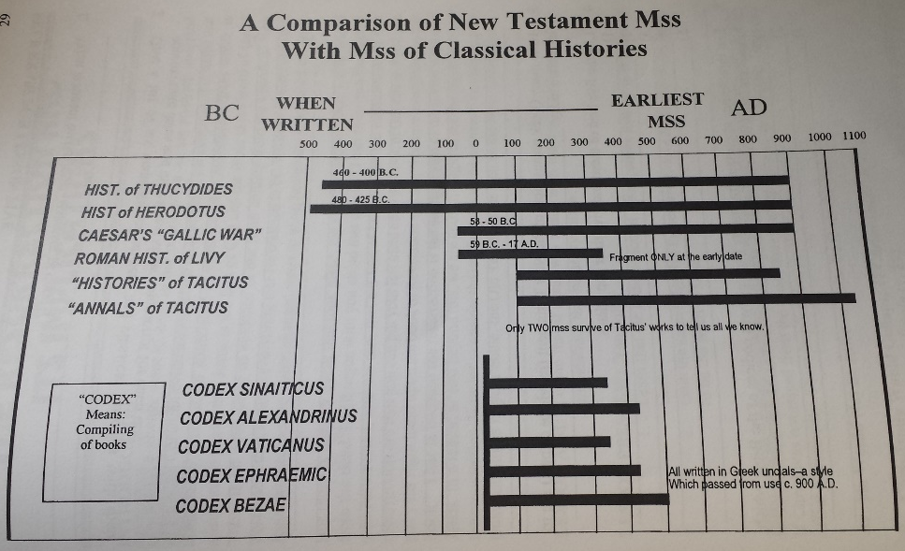
Scan from “The Case for Historic Christianity” by Edward C. Wharton

- Over _____________ copies of the Greek New Testament in whole or in part
  - Many other MSS in other languages dating back in history

Center for the Study of the New Testament Manuscripts- http://www.csntm.org
Christian Apologetics & Research Ministry- https://carm.org/manuscript-evidence
More comparisons of texts- http://en.wikipedia.org/wiki/Biblical_manuscript

CONCLUSIONS

The evidence for manuscript attestation for the New Testament FAR EXCEEDS many other classical histories.

If we can accept classical histories as being accurate with far less evidence for their reliability, we MUST accept the New Testament writings as being accurate.

“If the New Testament were a collection of secular writings, their authenticity would generally be regarded as beyond all doubt.” (FF Bruce, The New Testament Documents, p. 15)

NOTES
____________________________________________________________________________________________________________________________________________________________________________________________________________________________________________________________________________________________________________________________________________________________________________________________________________________________________________________________________________________

